Name of Student: HARPAL BIDAWAT | PRN:25070122080
Semester: III | Year: AY 2026-27
Subject: Programming with Java
ASSIGNMENT No: 25
TITLE: Write a Java program using the Thread class to create multiple threads and
demonstrate their lifecycle.
Problem Statement
Write a Java program using the Thread class to create multiple threads and demonstrate their lifecycle.
Learning Objectives
To create and manage multiple threads using the Thread class.
Programme
1.Create a program where multiple threads print numbers simultaneously
2. Create a Java program using multiple threads to simulate bank transactions. One thread performs deposit operations, and another performs withdrawal operations, both printing transaction details simultaneously.
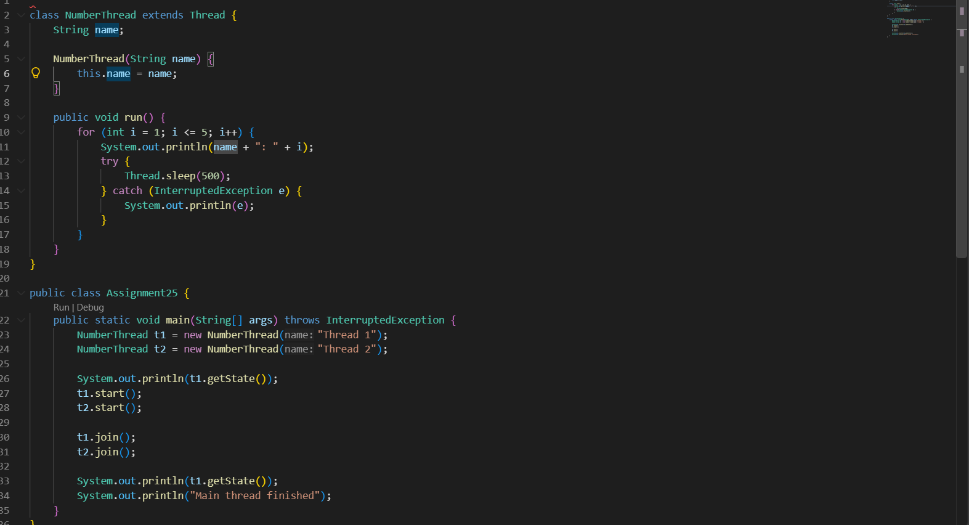
Output
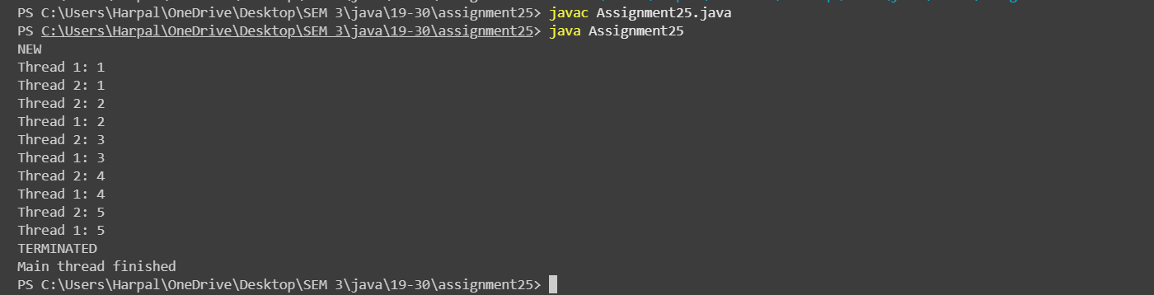
Conclusion
The program demonstrates multithreading by extending the Thread class and overriding the run() method. It uses start(), sleep(), join(), and getState() to demonstrate concurrent execution and thread lifecycle states.

